**Online Course**

**Management System**

***Submitted by***

**Monica S 19CS058**

*A report for the Engineering Exploration of the project*

*Submitted to the Faculty of*

**COMPUTER SCIENCE AND ENGINEERING**

***In partial fulfilment for the award of the degree***

***of***

**BACHELOR OF ENGINEERING**

**IN**

**COMPUTER SCIENCE AND ENGINEERING**

**SRI SHAKTHI**

**INSTITUTE OF ENGINEERING AND TECHNOLOGY**

**COIMBATORE – 641 062**

**Autonomous Institution, Accredited by NAAC with “A” Grade**

**JUNE 2022**

**ABSTRACT**

Requirements definition and management is recognized as a necessary step in the delivery of successful systems and software projects, discipline is also required by standards, regulations, and quality improvement initiatives. Creating and managing requirements is a challenge of IT, systems and product development projects or indeed for any activity where you have to manage a contractual relationship. “ONLINE COURSE MANAGEMENT SYSTEM” undertaken has a project. This project is a web-based application specially for aspiring learners and instructors. This system mainly deals to manage the online courses for users. This application has been designed and developed a comprehensive web-based system to better support the students benefit and requirement. By using this application will make the students less wasted time, and they will be able to easily get all the studies information from their teachers. As a result, they will be able to continue their studies better This take a look at develops an adaptive e-mastering platform wherein the learner is permitted to reply questions or resolve issues primarily based totally on potential or pace. The software program will undertake the Agile model. To accomplish this project, MERN Stack is used in the project. This project helps in safety, quality, and overall standard of learning amongst learners in educational institutions.

**ACKNOWLEDGEMENTS**

This project wouldn’t have been possible without Mrs. Banu Priya whose guidance proved to be invaluable throughout the entire project. And also helped us to overcome plenty of technical hindrances along the way and kept us motivated the whole time. We thank all our friends who were very generous to helped us understand our domain better and kept pushing us to write better code.

|  |  |  |
| --- | --- | --- |
| **CHAPTER NO.** | **TITLE** | **PAGE NO.** |
|  | **ABSTRACT** | **II** |
|  | **LIST OF FIGURES** | **IV** |
| **1** | **INTRODUCTION** | **1** |
|  | 1.1 INTRODUCTION | 1 |
|  | 1.2 OBJECTIVES | 1 |
| **2** | **METHOD** | **2** |
|  | 2.1 WORKING EXPLANATION | 2 |
|  | 2.2 AGILE MODEL | 4 |
| **3** | **RESULTS** | **4** |
|  | 3.1 OUTPUT SNAPSHOTS | 4 |
| **4** | **CONCLUSION** | **12** |
| **5** | **FUTURE ENHANCEMENT** | **13** |
|  | **REFERENCES** | **14** |

**INTRODUCTION**

* 1. **INTRODUCTION**

The generation of students born with digital technology brings with them a significantly different approach to learning. The combination of technologies and the new generation’s digitally-enhanced cognitive and social skills will need new solutions in the current concept of Learning. These are achieved by this “Online Course Management System” and also it provides easy user interface and security. Online Course Management System has been created with the aim of providing the students and faculty an easier and convenient way to impart knowledge. The functions of this system are done partly manually. Automated functions too play a role in completing the structure of the system.

* 1. **OBJECTIVES**
* Every user needs to complete the registration with verified mail ID for security purposes.
* Easy way of accessing the website with login portal.
* This site makes the user to feel the easy user-interface mode with all delight features.
* The user can enrol in the course and start the learning in their own pace.
* The courses are placed in their respective categories, so search is quick.
* Courses are bookmarkable for easy accessing.
* The users can register themselves as instructors to share their knowledge.
* Instructors can make the content and the students to learn from them.
* Comment section is available where doubts and issues can be cleared.
* Rating the enrolled courses is available for students.
* Instructors can edit and delete the courses.
* Develop a feature which will be used to make sure that all the levels of learning are covered in a course.
* Recommended Courses are used here to showcase the preferred courses of the learner.

**METHOD**

**2.1 WORKING EXPLANATION**

The user has to register themselves with appropriate Name, Email ID and, Password which satisfies the constraints. If any issue in matching the constraints, the warning will be thrown immediately. The registration will be completed only if Email ID is verified through OTP. If registration is done without OTP verification, then the login will fail. To gain the access for login, the user has to verify the Email ID by the OTP verification for the same Email ID. And then, user can login into the website with their Email ID and password. If login fails, appropriate warning will be thrown. The warning helps the user to move further. The sessions are passed for each login. The session time for each login is 5 hours. The user can go through the courses available in the website. The user can search the course by the course name or by the instructor’s name. The user can also check the courses by the categories. If user want to learn from the course, the user can enrol in the course and start their learning pace. The user can bookmark the courses for ease access of the courses. Each course has progress bar, which denotes the completion of the course. The user can enable and set out the preferences and check all the recommended content in the homepage. The user can rate the course by providing the stars. And also, the user can comment their issues and doubts. So, instructor can clarify the doubts and also try to resolve the issues. The user can share the knowledge by enrolling as instructor and the user can create the course with refreshing content. The instructor can add, edit and delete the course. The instructor can make videos and share them in the courses. Effectivity of progress bar is shown only if videos are seen by the learner. The instructor can publish the courses with pre-requisites and some words to inspire the learners. The course introduction is provided for all courses by the instructor. The learner can start the course after referring all the introduction of the course. The user and instructor can logout from the site after the using the site. If not, the session maintenance will handle the logging off from the session when the session time meets it. As a result, the goal was to simplify the students study easier in a secured manner with easy user-interface and move them forward.

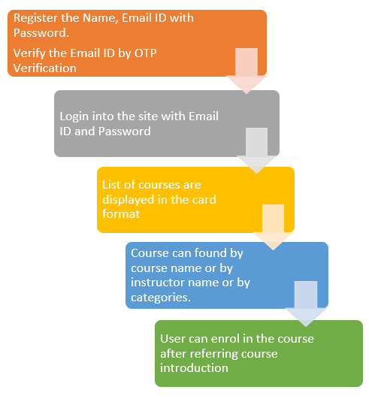

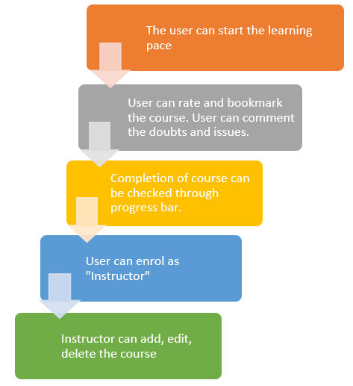

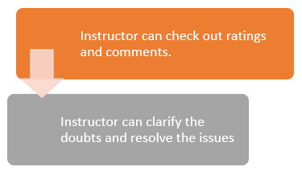

**2.2 AGILE MODEL**

To overcome the limitation of the waterfall model, the agile model was introduced. Agile model is the combination of iterative and incremental software development model. In the agile model, the requirements are break up into many parts, called iterations, and then developed incrementally. In this model, each iteration is planned, designed, implemented, tested and deployed to the customers to take the feedback. If any changes required then the modification is done at that iteration then carry on the project. Any error can be fixed at each iteration so there is no issue about presence of errors in the project.

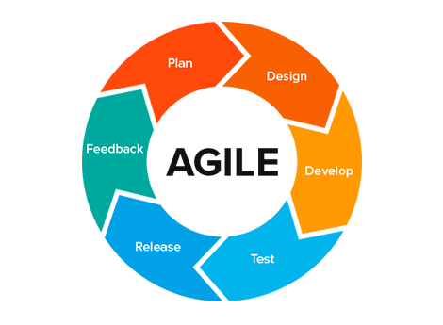

**FIGURE 2.2.1 AGILE MODEL**

* To establish close contact with the customer during development and to gain a clear understanding of various requirements, each Agile project usually includes a customer representative on the team. At the end of each iteration stakeholders and the customer representative review, the progress made and re-evaluate the requirements.
* Frequent delivery of incremental versions of the software to the customer representative in intervals of few weeks.
* Requirement change requests from the customer are encouraged and efficiently incorporated.
* It emphasizes on having efficient team members and enhancing communications among them is given more importance.

**RESULTS**

**3.1 OUTPUT SNAPSHOTS**

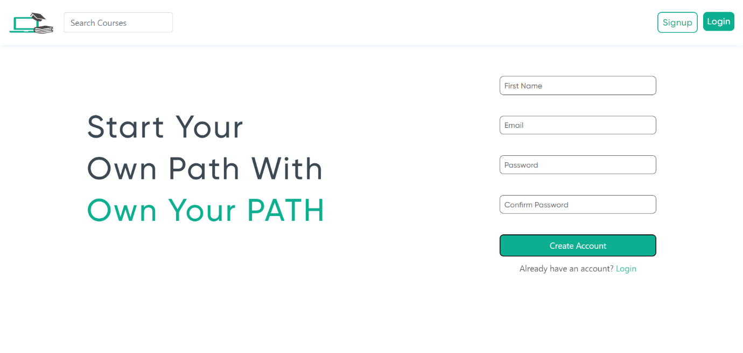

**FIGURE 3.1.1 REGISTERATION PAGE**

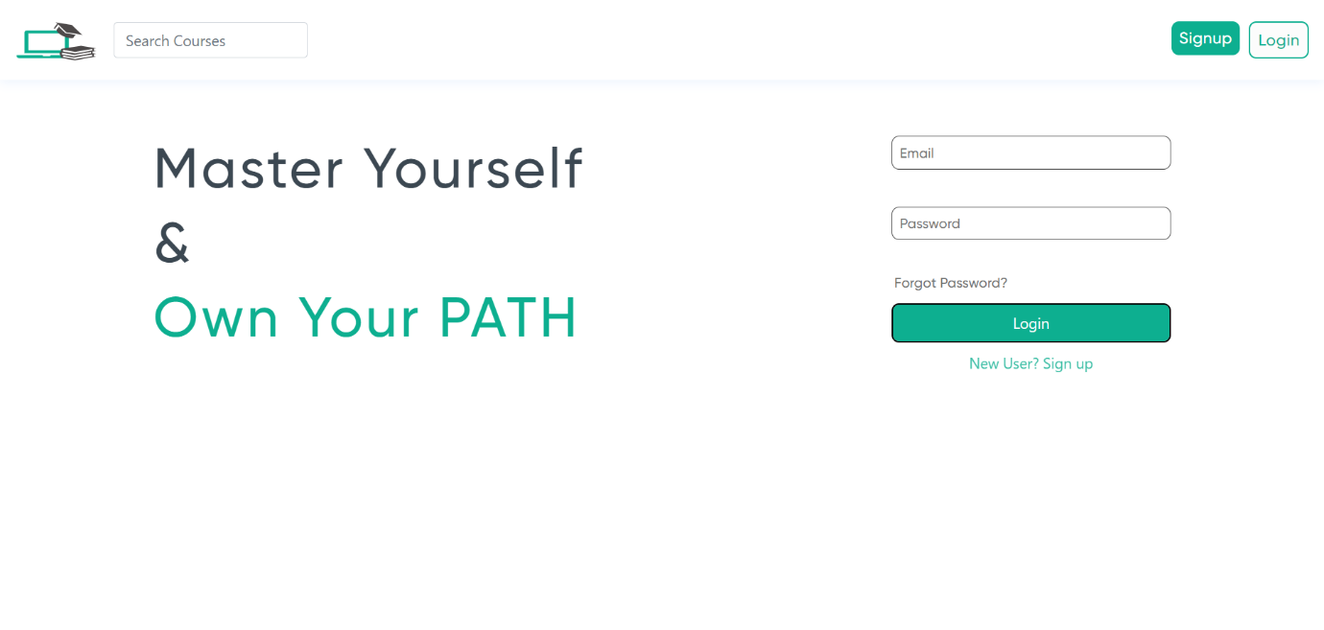

**FIGURE 3.1.2 LOGIN PAGE**

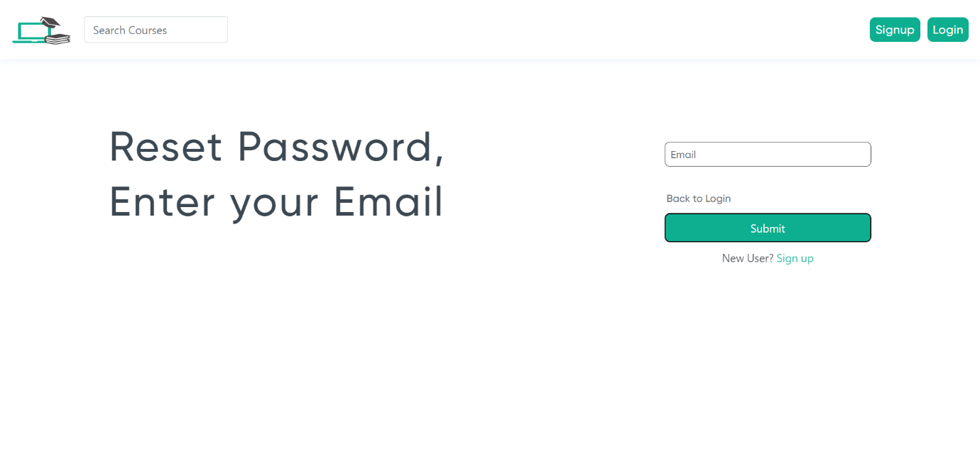

**FIGURE 3.1.3 RESET PASSWORD PAGE**

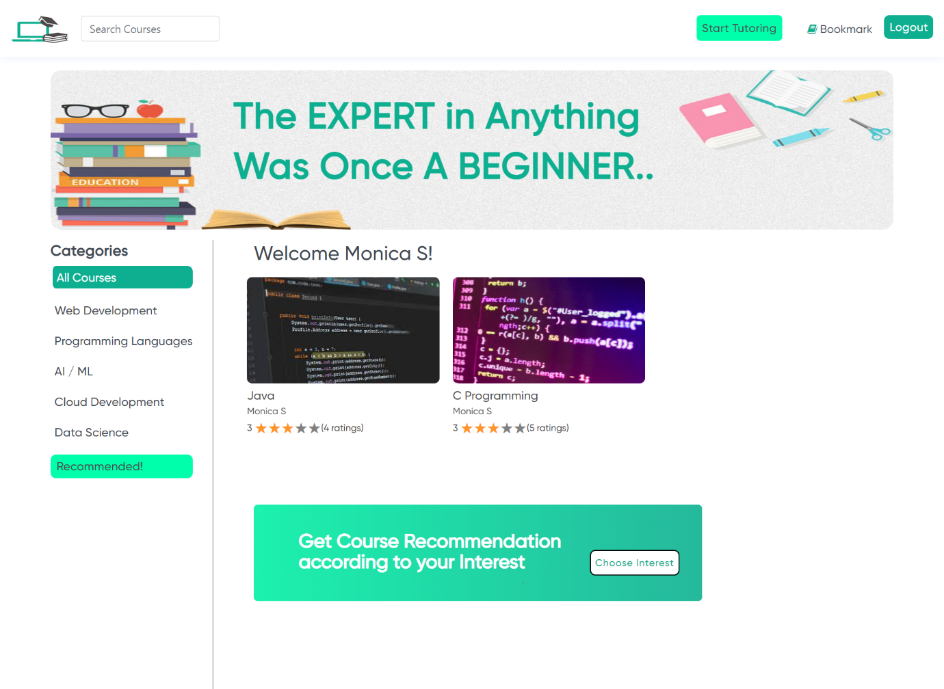

**FIGURE 3.1.4 HOMEPAGE**

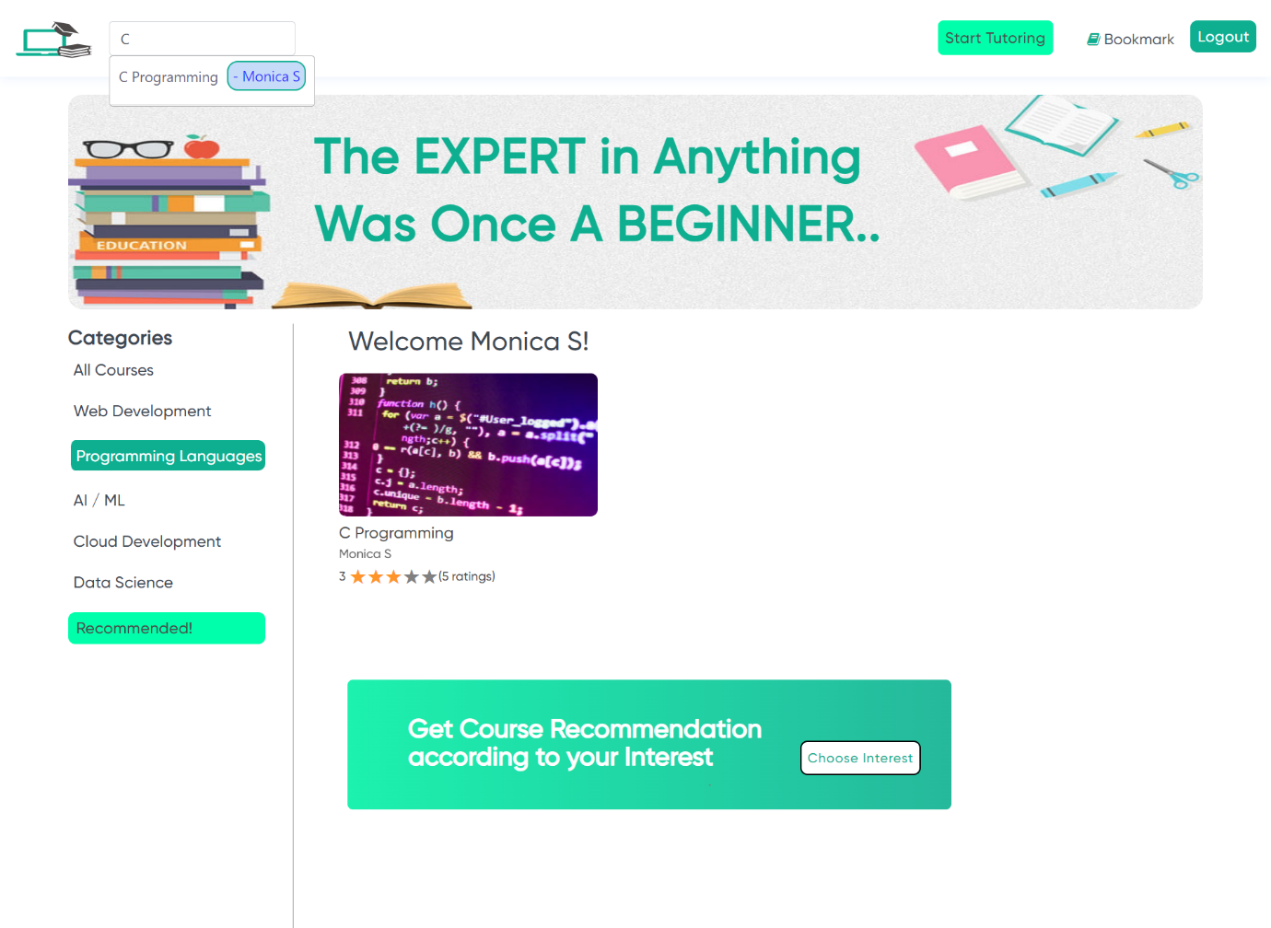

**FIGURE 3.1.5 SEARCH INTERFACE**

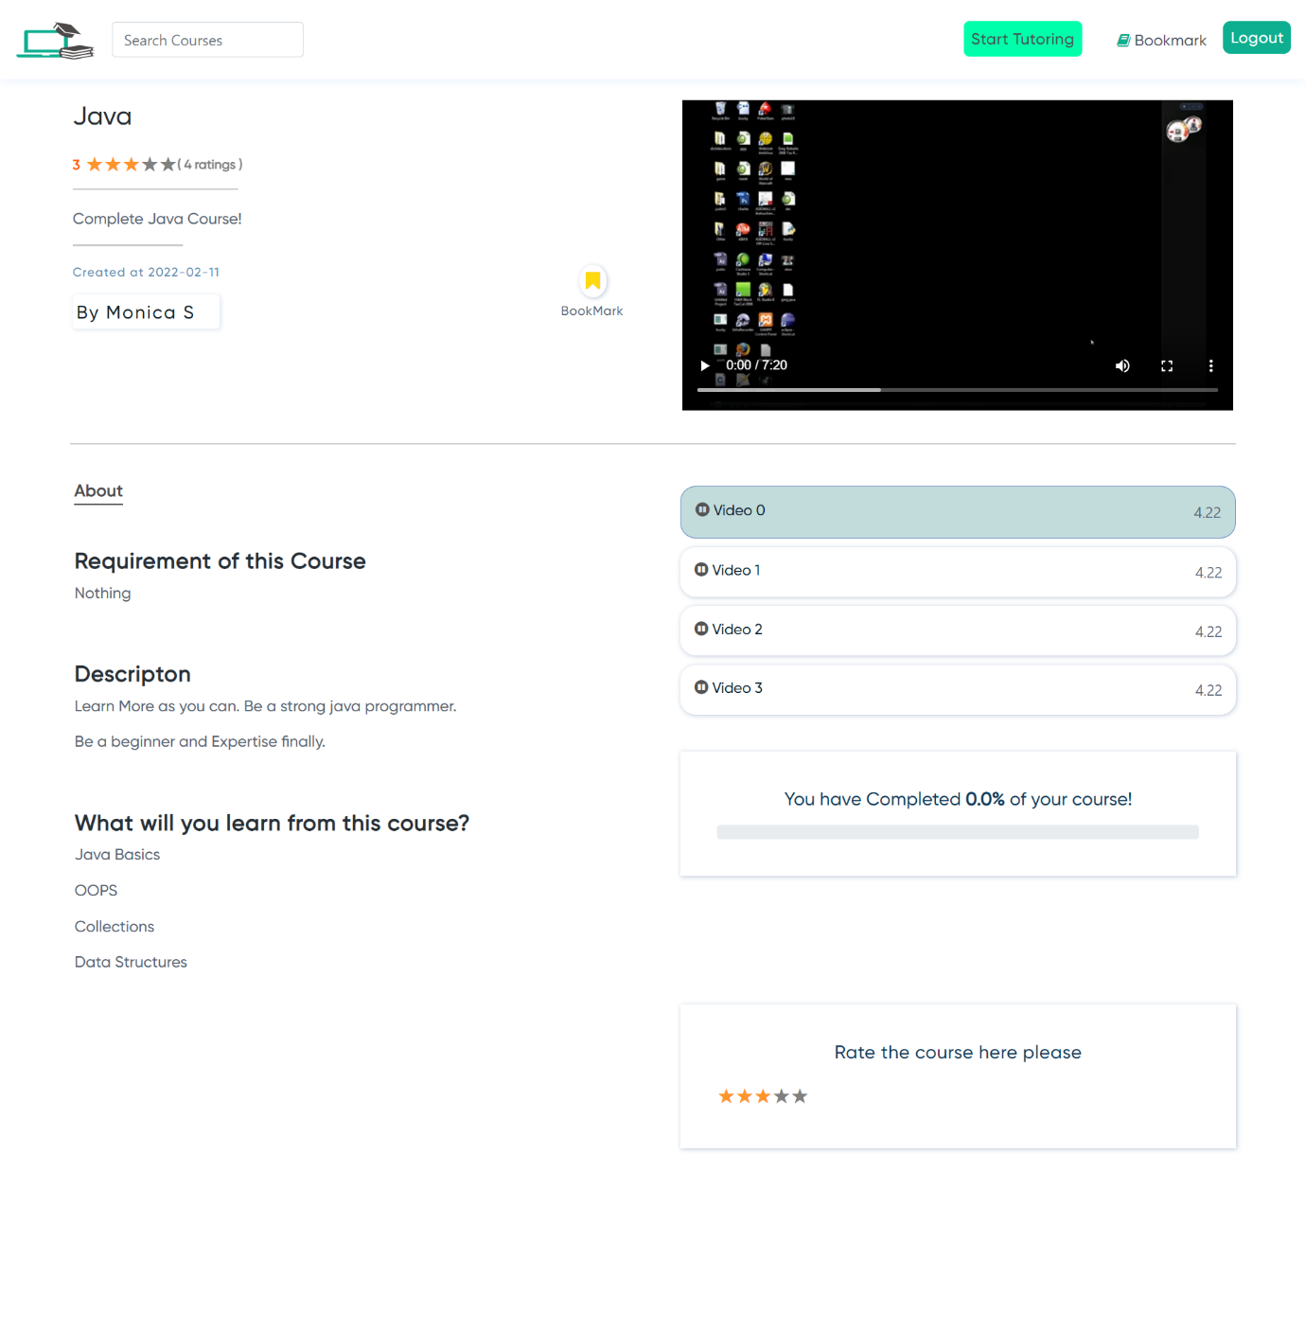

**FIGURE 3.1.6 COURSE PAGE**

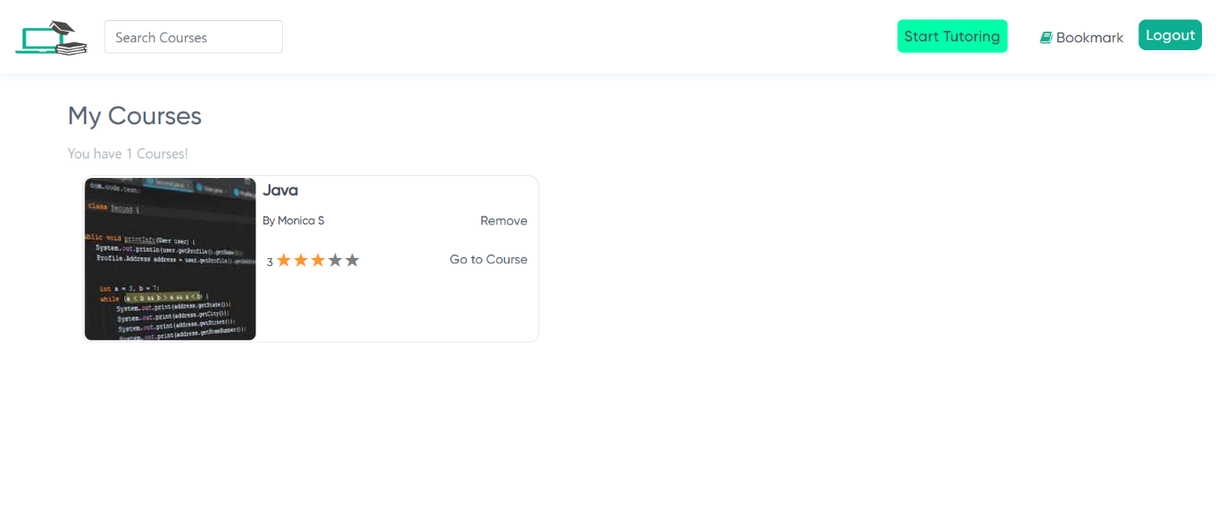

**FIGURE 3.1.7 BOOKMARK PAGE**

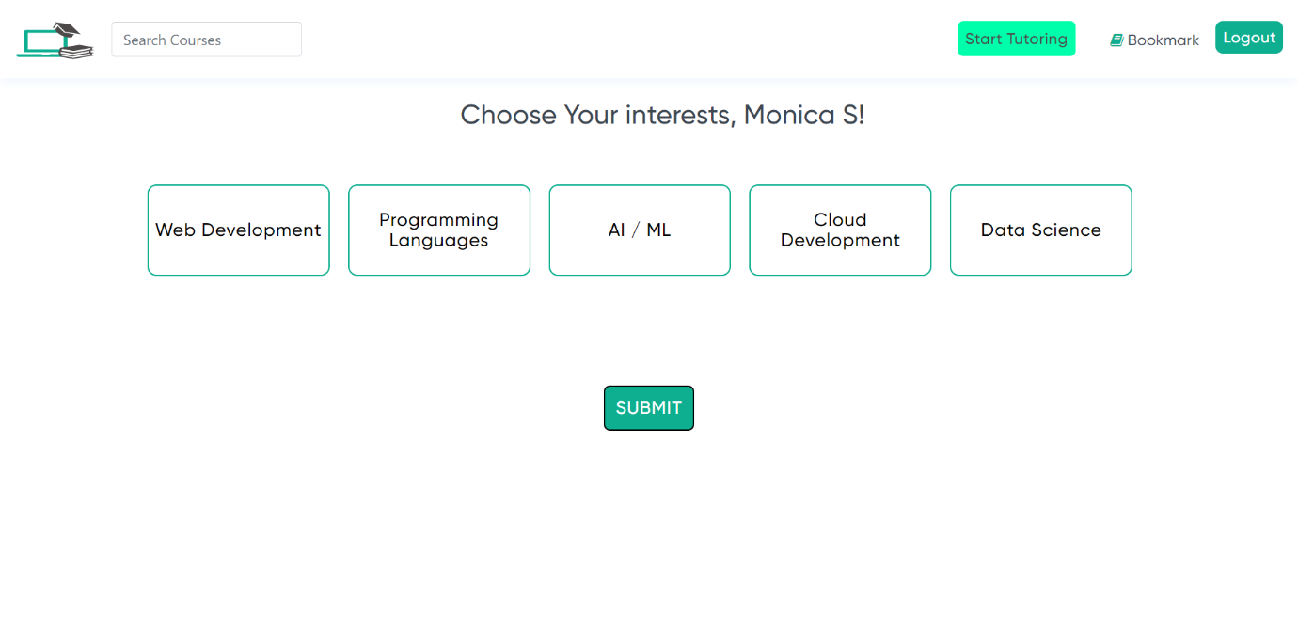

**FIGURE 3.1.8 PREFERENCE PAGE**

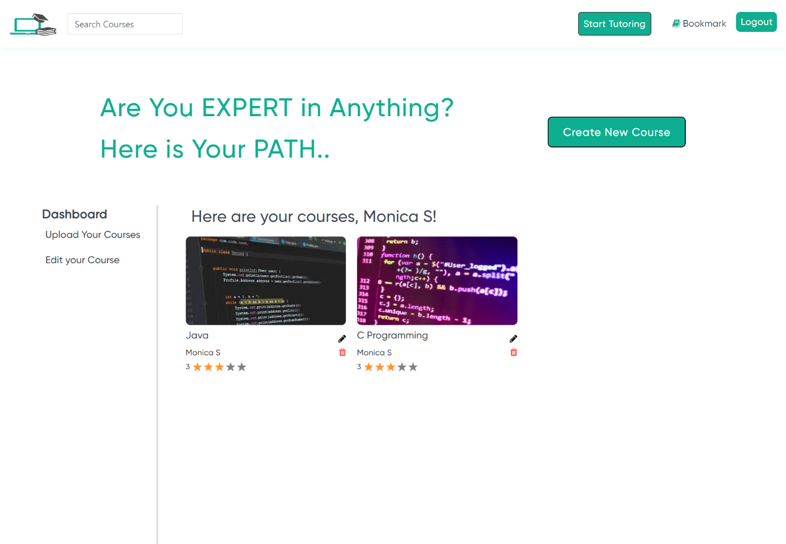

**FIGURE 3.1.9 INSTRUCTOR PAGE**

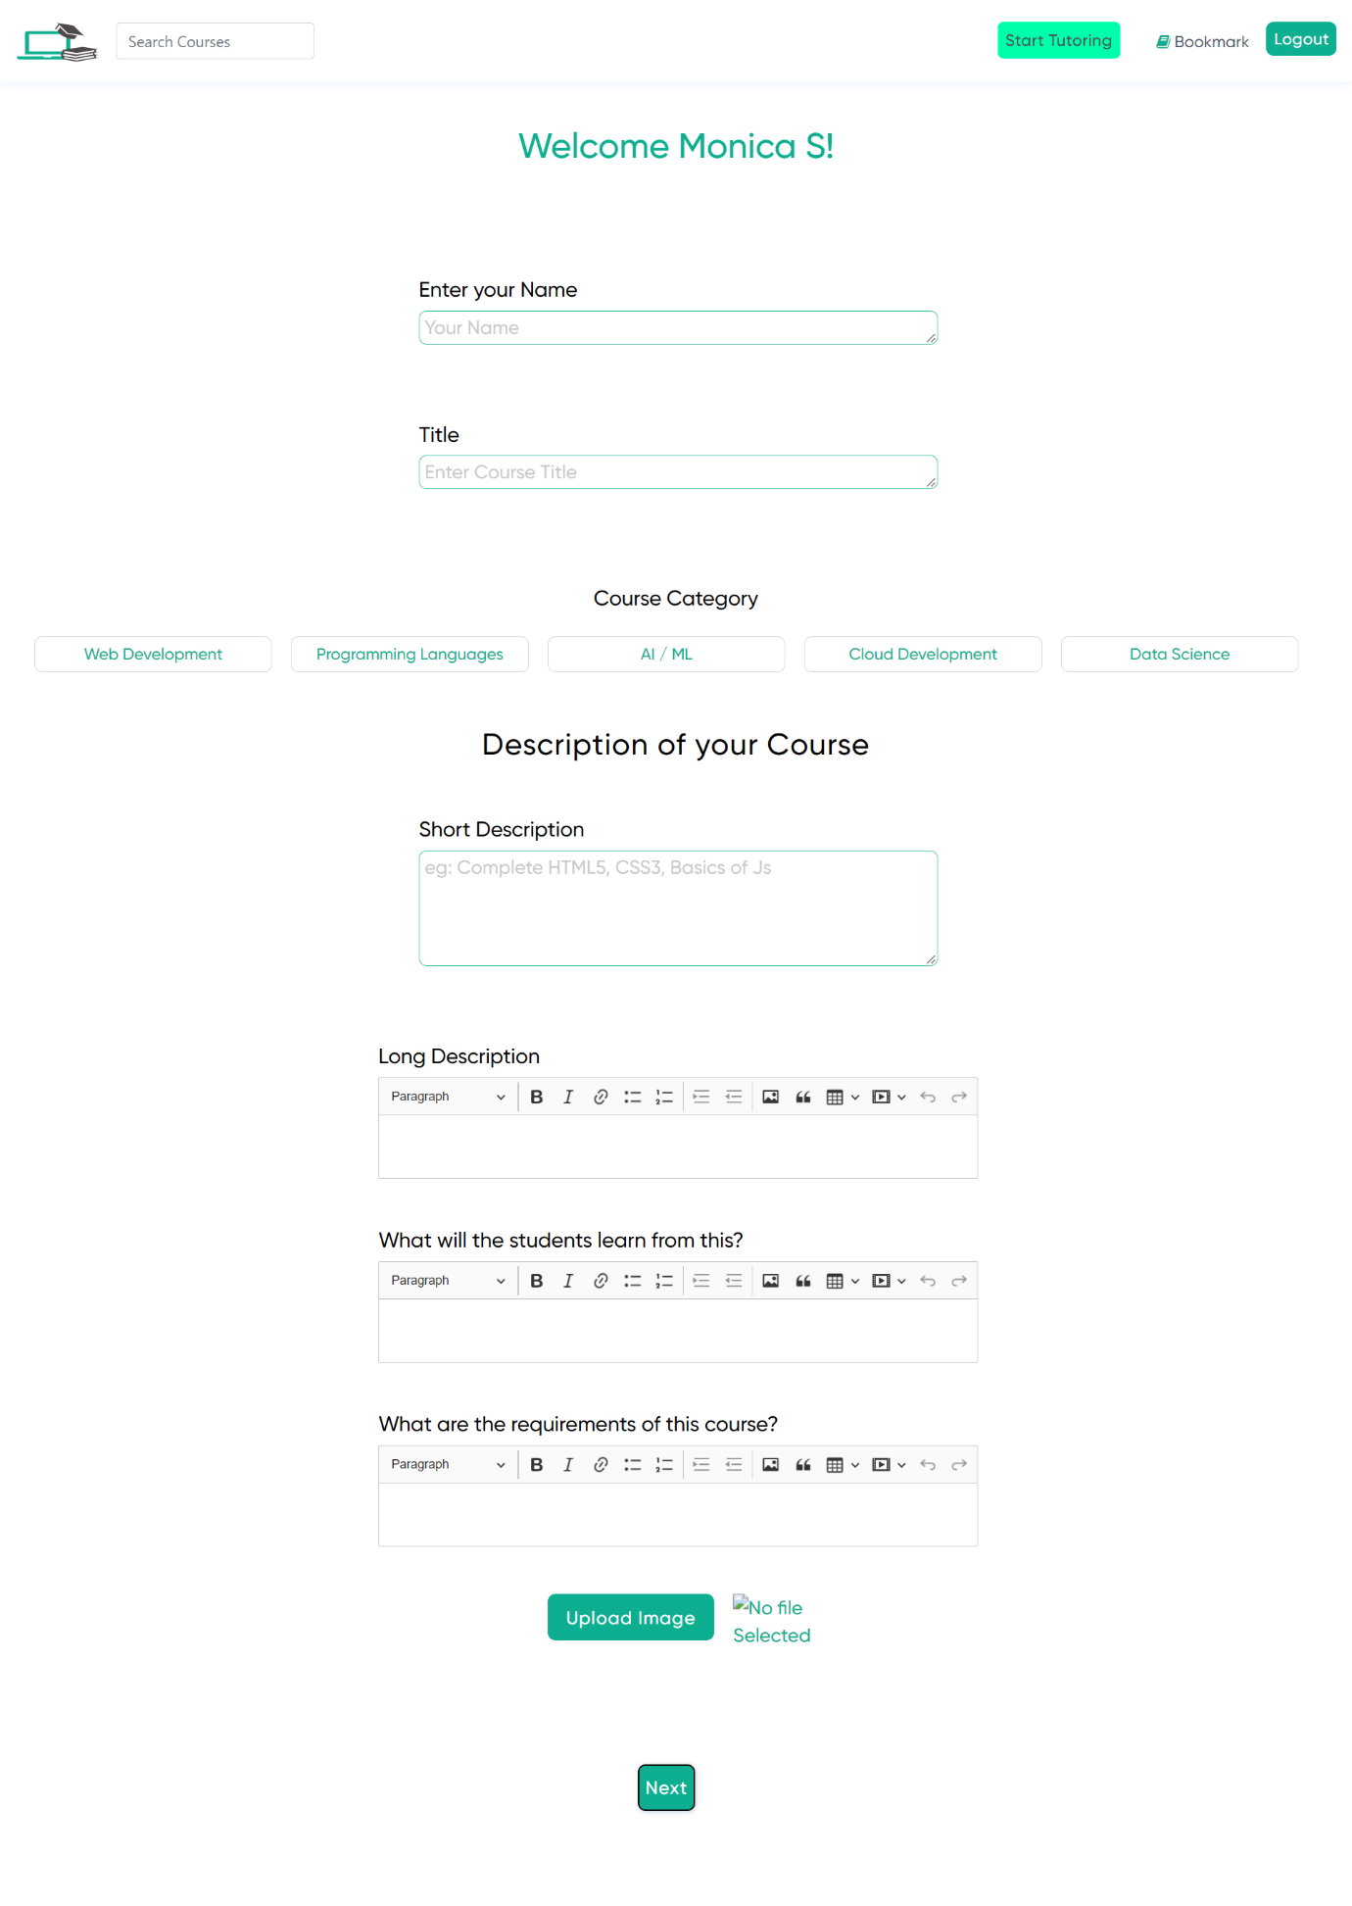

**FIGURE 3.1.10 COURSE ENTRY PAGE**

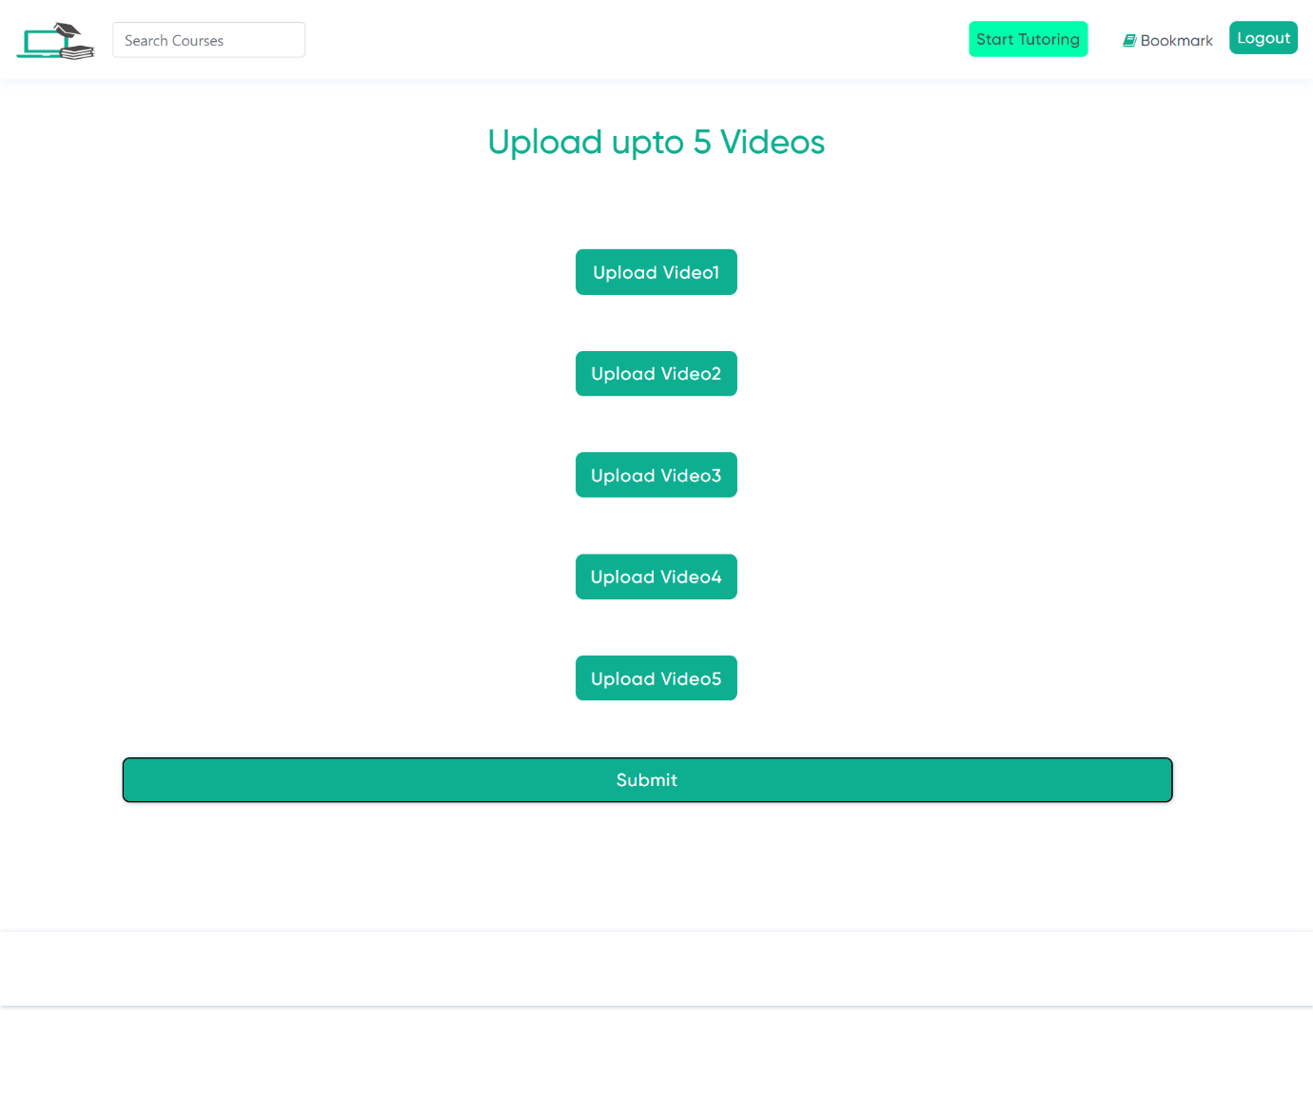

**FIGURE 3.1.11 VIDEO ENTRY PAGE**

**CONCLUSION**